Lab #8: Inventory System

*Carson Kramer*

*May 2nd, 2023*

ALGORITHM

* Main function (using dynamic memory allocation, deallocation, and virtual methods)
  + Prompting the user to make a Paint selection. Choose either:
    - Enter from file
    - Enter a color and a number of paint cans for the Paint
  + Use uniform_real_distribution class to generate a random size in percent
  + Dynamically create paint object & initialize
    - Save object in array “paints” of size 7
* Repeat bullet points 10 times until array is full
* After, prompt following menu:
  + Adjust Inventory
  + View Help for Selection
  + View Current Inventory
  + Print Inventory to a File
  + Quit
* After finished, Cycles through the 7 selections and invokes the Help function, along with displaying the color, the gloss_level, and the number of cans in inventory

Class Paint

* Public:
  + Default constructor
    - initializes the gloss_level to zero
    - outputs the message “Invoking the default Paint constructor.”
  + 2-Argument constructor
    - color and gloss_level to be set by the client
    - output the message “Invoking the 2-argument Paint constructor.”
  + Destructor
    - output the message “Invoking the default Paint destructor.”
  + Get and set functions
  + Virtual help() function
    - unable to call help from a general paint object
* Private:
  + (string) color
  + (float) gloss_level
  + (int) numOfCans

Flat, Eggshell, Satin, Semi-Gloss, and High-Gloss classes

* Public:
  + Default constructor
    - initializes the gloss_level to zero
    - outputs the message “Invoking the <name> Paint constructor.”
  + 2-Argument constructor
    - color and gloss_level to be set by the client
    - output the message “Invoking the 2-argument <name> Paint constructor.”
  + Destructor
    - output the message “Invoking the <name> Paint destructor.”
  + Virtual help() override function
    - custom help messages printed

SCREEN-SHOTS OF RUNNING PROGRAM

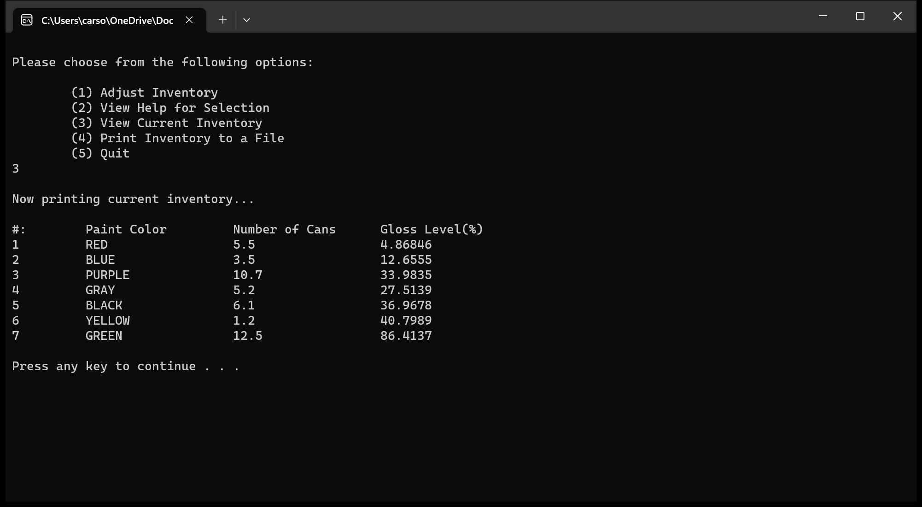

INTEGRITY STATEMENTS

* I have not shared the source code in my program with anyone other than the pre-approved human sources.
  + *Please include a note here if you have used one or more of the pre-approved human sources or received special permission from me.*
* I have not used source code obtained from another student, or any other unauthorized source, either modified or unmodified.
* If any source code or documentation used in my program was obtained from another source, such as the course textbook or course notes, that has been clearly noted with a proper citation in the comments of my program.
  + It would also be helpful to include a note here of which sources you used
* I have not knowingly designed this program in such a way as to defeat or interfere with the normal operation of any machine it is graded on or to produce apparently correct results when in fact it does not.

Note: These statements serve as your personal promise that the above is true. If I find that you have not been true to ALL of the four statements above, you will get a zero for the assignment and receive an academic violation report (which goes on your academic record). Both are minor compared to the loss of your integrity.